**Iowa Liquor sales - Gallery links of Azure ML experiments**

**1. Sampling 1 (Original dataset of 4.13 GB sampled at 0.01 rate)**

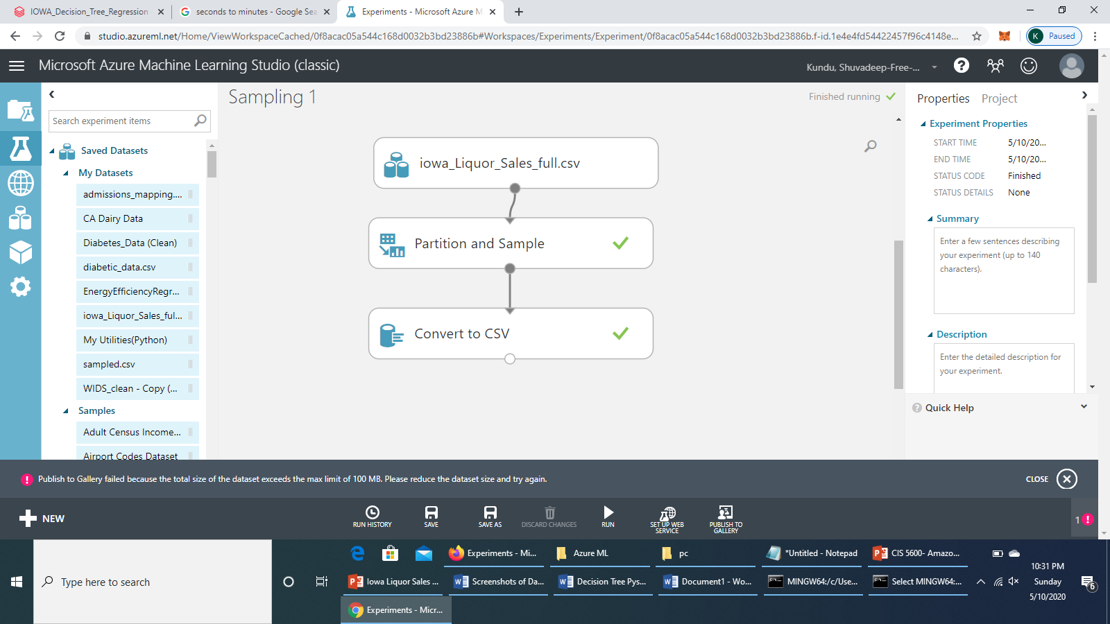

**2. Linear Regression**

<https://gallery.cortanaintelligence.com/Experiment/Iowa-liquor-sales-Linear-Regression-Cross-Validation-Tuning-Model-Hyperparameters>

<https://gallery.cortanaintelligence.com/Experiment/Iowa-liquor-sales-Linear-Regression-Cross-Validation-Tuning-Model-Hyperparameters-New>

**3. Decision Forest Regression**

<https://gallery.cortanaintelligence.com/Experiment/Iowa-liquor-sales-Decision-Tree-Forest>

<https://gallery.cortanaintelligence.com/Experiment/Iowa-liquor-Sales-Decision-Tree-Forest-New>

**4. Boosted Decision Tree Regression**

<https://gallery.cortanaintelligence.com/Experiment/Iowa-Liquor-Sales-Boosted-Decision-Tree-Regression>

<https://gallery.cortanaintelligence.com/Experiment/Iowa-Liquor-Sales-Boosted-Decision-Tree-Regression-New>